Schneider Electric makes steady progress toward 2025 sustainability targets

Schneider Electric, the leader in the digital transformation of energy management and automation, announced today the results of its sustainable impact program for the second quarter of 2022.
Schneider’s Sustainability Impact (SSI) scored 4.17 out of ten, relative to its 4.70 year-end target. The SSI dashboard measures Schneider’s Environmental, Social and Governance (ESG) performance. It details the progress made on each of the company’s global and local sustainability goals relative to long-term commitments on climate, resources, trust, equal opportunities, generations, and local communities.
The publication of Schneider’s latest SSI scores coincides with Earth Overshoot Day, the date at which more of the Earth’s resources have been consumed than can be replenished. As Earth Overshoot Day in 2022 has occurred one day earlier than last year, it serves as a stark reminder of the need to urgently address humanity’s adverse impact on the planet.
"Our planet is burning, literally. We have to face the reality in front of us and keep accelerating our sustainability efforts," said Gwenaelle Avice-Huet, Schneider Electricity’s Chief Strategy and Sustainability Officer. “As an Impact company, we are convinced that we can help each other with technology, collaboration, and trust. Advancing on our Sustainability Impact program is not about ESG compliance. It’s about embarking and working with our entire ecosystem of employees, clients, suppliers, and partners to progress together.”
Second quarter 2022 sustainability highlights
- Schneider Electric’s EcoStruxureTM solutions helped customers and suppliers make significant decarbonization progress and reduce their CO₂ emissions by 381 million tonnes since 2018. In June, Schneider Electric and Hitachi Energy agreed to collaborate on green electricity solutions for renewables, data centers, mining and other sectors of industry.
- Schneider Electric just expanded its biodiversity pledge to use only deforestation-free wood across its supply chain and operations by 2030.
- Schneider Electric provided +1.1 million people with access to green electricity in Q2 2022, bringing it to +6.4 million since January 2021.
- In 2022, 82% of Schneider employees feel confident to report an unethical conduct. A good progress since last year (+1pt) in its commitment to provide a trusted environment and Speak Up culture.
- Schneider Electric launched its Sustainability School to educate employees on climate and social issues and encourage them to take action and deliver impact in every aspect of their lives.
- Schneider Electric’s teams in countries and regions continue to play a specific role in ensuring the maximum impact of their locally-led sustainability initiatives, including projects in France, USA, China and India.

Detailed results and highlights of the SSI program are presented in the Q2 2022 report, which includes the following overview:

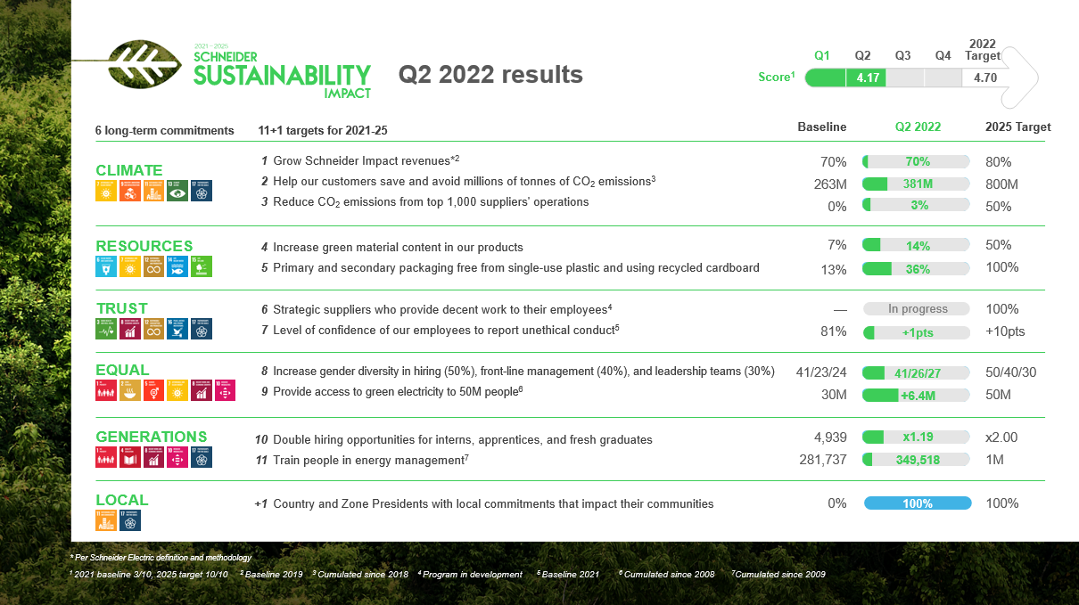

Because of its robust sustainability programs with concrete and measurable progress, Schneider Electric continues to link its financing instruments to the Group sustainability trajectory. During the first half of the year, the Group set up a €2,7 Billion euros bank facilities with a pricing indexed on the annual performance of the Schneider Sustainability Impact (SSI).

Recent sustainability awards and recognition:
  - Schneider Electric recognized as the 2022 Microsoft Energy & Sustainability Partner of the Year
  - Schneider Electric wins “Water Technology Company of the Year” in Global Water Awards 2022
  - Schneider Electric ranks 2nd in Gartner Top 25 Supply Chain

Read more about Schneider’s Sustainability Impact results and highlights:
- Q2 2022 Schneider Sustainability Impact report
- Half-year 2022 Financial and Extra-financial document

Schneider Electric’s Environmental, Social and Governance (ESG):
- Sustainability reports page
- Frequently Asked Questions (FAQ)
- Sustainability Disclosure Dashboard 2021

About Schneider Electric

Schneider’s purpose is to empower all to make the most of our energy and resources, bridging progress and sustainability for all. We call this Life Is On.

Our mission is to be your digital partner for Sustainability and Efficiency.

We drive digital transformation by integrating world-leading process and energy technologies, end-point to cloud connecting products, controls, software and services, across the entire lifecycle, enabling integrated company management, for homes, buildings, data centers, infrastructure and industries.

We are the most local of global companies. We are advocates of open standards and partnership ecosystems that are passionate about our shared Meaningful Purpose, Inclusive and Empowered values.

www.se.com

Follow us on:
Discover Life Is On

Discover the newest perspectives shaping sustainability, electricity 4.0, and next generation automation on Schneider Electric Insights

Hashtags: #Sustainability, #ESG, #Impactcompany

